**Final Task – First Part Report**

***GUI:***

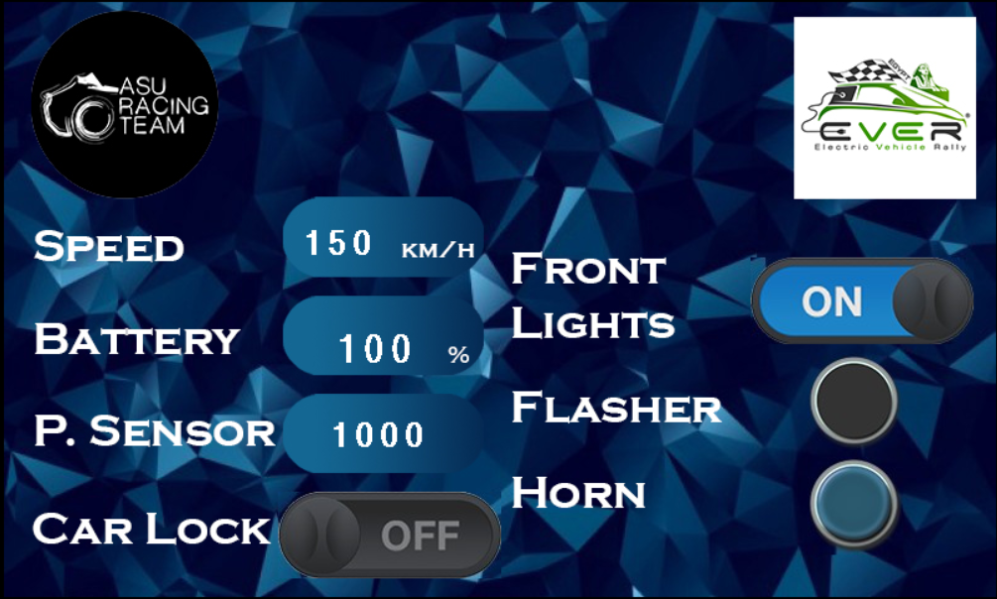

* Readings from Arduino are displayed on the left side.
* Input buttons on the right.
* Front lights toggle button.
* Flasher and horn are hold buttons.

***Code:***

* Secondary Arduino reads values from potentiometer, voltage sensor, ultrasonic sensor and sends them to primary Arduino.
* Primary Arduino reads data from lock button then transmits the first 4 pieces of data to LCD.
* Primary Arduino reads data from LCD and switches lights, flasher, and horn accordingly .
* Addresses of each text box or button:

|  |  |
| --- | --- |
| ***Text/Button*** | ***Address*** |
| Speed | 0x1000 |
| Battery Percentage | 0x1100 |
| Parking Sensor | 0x1200 |
| Car Lock | 0x1300 |
| Front Lights | 0x1400 |
| Flasher | 0x1500 |
| Horn | 0x1600 |